The whole idea for this application was born, when I with the other guy (bunnyhoney) were updating polish langpack. After some changes with unicode encoding (UTF8 without BOM to full UTF8) the tool that we had for combining translation file (some dos script file make.cmd) just couldn't produce the right output file. We didn't know how to deal with this encoding issue. So then I thought, that I could probably write my own app. Later bunnyhoney asked me to add the feature, which could search for duplicated entries in langpack file. This version was purely polish. I though - why shouldn't I modify my app a little so that it would have an english interface and present it to wider public. So here it is.

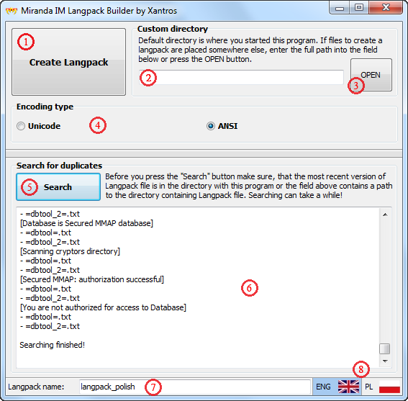

What it can do:

- create translation file (langpack) from many smaller text files containing translations for eg. different plugins,

- encode langpack in either UTF8 or ANSI,

- look for duplicated entries and tell in which files they are located.

Application description:

How does it work:

Default directory (if field 2 is left empty) is where you have started this application. It's quite convenient, because you don't have to enter the path every time you create a Langpack. So if we have for exampl "C:\Miranda Langpack" directory with files like =CORE=.txt, =HEAD=.txt etc and inside is also a directory named "Plugins" with translations for each plugin, then place mLangpack.exe in "C:\Miranda Langpack". IMPORTANT! For translation file to work you should have =HEAD=.txt file with at least "Miranda Language Pack (...)" line inside.

For searching function to work you must specify file name (without ".txt" extension) in the field 7 and, if it's necessary, also path in the field 2. It can appear, that the application froze and isn't working, but everything is ok. Langpacks can have tens of thousands of lines inside, so all the searching can take some time. It shouldn't take more than 10 seconds to finish, so be patient.

Command line. YES! To make some things easier you can start the app from command line (or just create a shortcut) with this options:

-eng

- starts app with english interface (not required, it starts with english interface anyway, but oh well..)

-pl

- starts app with polish interface

-ansi

- starts app with ANSI encoding selected

-name file_name

- field 7 will have file_name entered by default

Example:

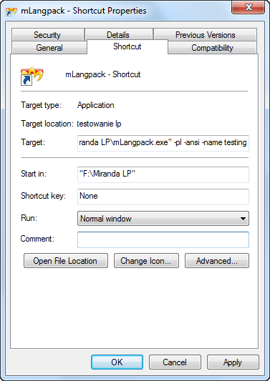

Link to download:

http://www.mediafire.com/?zt77pzhgz82i292